Course Management System — Basic Working
Tumhare system mein 4 modules hain:
- Student Registration
- Course Management
- Enrollment
- Fee Management
In 4 modules ka connection ye hai:
Student → Enrollment ← Course → Fee

👨‍💼 Admin Module — Course Management System
Admin system ka main user hoga jo students, courses, enrollments, fees aur system users ko manage karega.

1. Admin ka Role
Admin ke paas system ke tamam main modules ka access hoga.
- Students ko register, view, edit aur deactivate karna.
- New courses add, edit aur deactivate karna.
- Students ko courses mein enroll karna aur enrollment records dekhna.
- Students ki fees aur payment history manage karna.
- Dashboard par total students, courses, enrollments aur fee records dekhna.
- Reports dekhna aur payment records check karna.
- System ke users aur unke roles manage karna.
- System ke users aur unke roles manage karna.

2. Admin Login Page
Admin system mein login karke hi dashboard access karega.
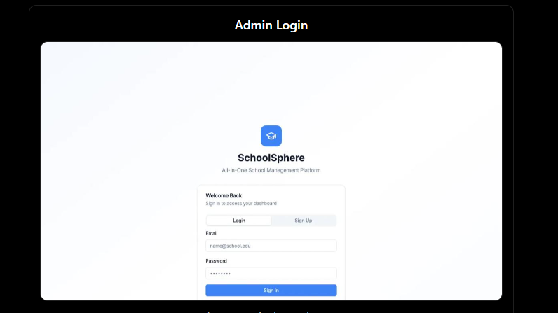
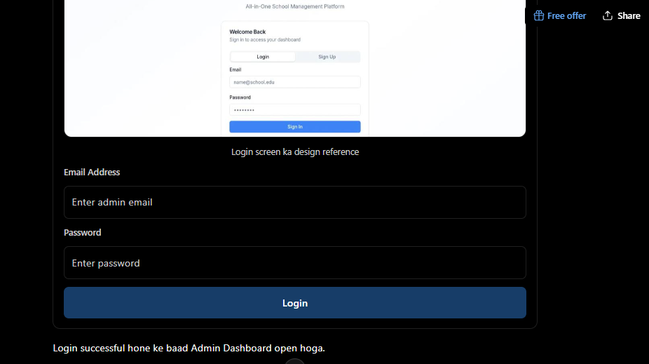

3. Admin Dashboard
Dashboard par admin ko ye information show hogi:
- Total Students
- Total Courses
- Total Enrollments
- Total Fees Collected
- Pending Fees
- Recent Registrations
- Recent Payments

4. Admin Sidebar
Admin ke sidebar mein ye menu items honge:

1. Student Registration Module

Purpose
Is module ka kaam students ka record maintain karna hai.

Is mein kya hoga?
- New student register hoga
- Student ki information save hogi
- All students ki list show hogi
- Student search hoga
- Student details dekhi ja sakengi
- Student information edit hogi
- Student deactivate/delete hoga

Student Form mein:
- Student ID
- Student Name
- Father Name
- Email
- Phone
- Address
- Registration Date
- Status

Working
Student Form
↓
Register
↓
Student Database mein Save
↓
Student List mein Show

2. Course Management Module

Purpose
Is module ka kaam courses ko manage karna hai.

Is mein kya hoga?
- New course add hoga
- Course list show hogi
- Course search hoga
- Course edit hoga
- Course deactivate/delete hoga
- Course ki fee maintain hogi

Course Form mein:
- Course ID
- Course Name
- Description
- Duration
- Course Fee
- Available Seats
- Instructor
- Status

Working
Course Form
↓
Add Course
↓
Course Database mein Save
↓
Course List mein Show

3. Enrollment Module

Purpose
Is module ka kaam registered student ko kisi course mein enroll karna hai.
Ye module Student aur Course ko connect karega.

Is mein kya hoga?
- Registered students ki list se student select hoga
- Available courses ki list se course select hoga
- Course fee automatically show hogi
- Enrollment date save hogi
- Unique Enrollment ID generate hogi
- Enrollment status save hoga
- Duplicate enrollment prevent hogi

Working
Select Student
↓
Select Course
↓
Course Fee Automatically Show
↓
Create Enrollment
↓
Enrollment Database mein Save

Important
Enrollment ke waqt student manually type nahi hoga.
Student module mein jo students registered hain, wahi enrollment mein available honge.
Isi tarah course module mein jo courses added hain, wahi enrollment mein available honge.

4. Fee Management Module

Purpose
Is module ka kaam enrolled student ki course fee manage karna hai.

Is mein kya hoga?
- Enrollment select hoga
- Total course fee show hogi
- Paid amount enter hoga
- Remaining amount automatically calculate hoga
- Payment date save hogi
- Payment method save hoga
- Payment status automatically update hoga
- Payment history show hogi

Working
Select Enrollment
↓
Total Fee Show
↓
Enter Paid Amount
↓
Remaining Amount Calculate
↓
Payment Save
↓
Payment Status Update

Fee Status
Paid Amount = 0
↓
Unpaid

Paid Amount < Total Fee
↓
Partial

Paid Amount = Total Fee
↓
Paid

5. Ab 4 Modules ka Connection
Ye sabse important part hai:
STUDENT
│
│
↓
ENROLLMENT
↑
│
COURSE
│
↓
FEE
Lekin logically flow ye hai:
Student Register
↓
Course Available
↓
Student Enroll
↓
Fee Submit

6. Database mein kya hoga?
Sirf 4 main tables:
1. Students
2. Courses
3. Enrollments
4. Payments

Students
Student ki information store karegi.
student_id
name
father_name
email
phone
address
registration_date
status

Courses
Course ki information store karegi.
course_id
course_name
description
duration
course_fee
available_seats
instructor
status

Enrollments
Student aur course ka connection store karegi.
enrollment_id
student_id
course_id
enrollment_date
status

Payments
Enrollment ki payments store karegi.
payment_id
enrollment_id
paid_amount
payment_date
payment_method

7. Database Relationship
Students
│
│
↓
Enrollments
↑
│
Courses

Enrollments
│
↓
Payments

Relationships:
One Student
↓
Many Enrollments
One Course
↓
Many Enrollments
One Enrollment
↓
Many Payments
Iska reason ye hai ke partial payments support karni hain.

9. Overall UI Layout
┌─────────────────────────────────────────────┐
│ NAVBAR │
├──────────────┬──────────────────────────────┤
│ │ │
│ Dashboard │ │
│ │ │
│ Students │ MAIN CONTENT │
│ │ │
│ Courses │ Current Page │
│ │ │
│ Enrollments │ │
│ │ │
│ Fees │ │
│ │ │
└──────────────┴──────────────────────────────┘
Sidebar aur navbar fixed rahenge. Sidebar se jis page par click hoga, main content area mein woh page open hoga.

10. Final System Flow
Ab tumhein sirf ye flow yaad rakhna hai:
┌─────────────────────┐
│ 1. STUDENT │
│ Register Student │
└──────────┬──────────┘
↓
┌─────────────────────┐
│ 2. COURSE │
│ Add Course │
└──────────┬──────────┘
↓
┌─────────────────────┐
│ 3. ENROLLMENT │
│ Student + Course │
└──────────┬──────────┘
↓
┌─────────────────────┐
│ 4. FEE │
│ Submit Payment │
└─────────────────────┘

🎓 Course Management System — Complete UI

Overall Layout
Har page ka same layout hoga:
┌──────────────────────────────────────────────────────────────┐
│ Course Management System 🔍 Search 🔔 Admin ▼ │
├────────────────┬─────────────────────────────────────────────┤
│ │ │
│ 🏠 Dashboard │ │
│ │ MAIN CONTENT │
│ 👨‍🎓 Students │ │
│ │ │
│ 📚 Courses │ │
│ │ │
│ 📝 Enrollments │ │
│ │ │
│ 💰 Fees │ │
│ │ │
└────────────────┴─────────────────────────────────────────────┘
Navbar + Sidebar fixed rahenge. Sirf main content change hoga.

1️⃣ Dashboard Page
Dashboard sirf system ka overview dega.
┌─────────────────────────────────────────────────────────────┐
│ Dashboard │
│ │
│ ┌────────────┐ ┌────────────┐ ┌────────────┐ ┌───────────┐ │
│ │ 👨‍🎓 │ │ 📚 │ │ 📝 │ │ 💰 │ │
│ │ Students │ │ Courses │ │ Enrollments│ │ Fees │ │
│ │ 120 │ │ 12 │ │ 180 │ │ Rs. 500K │ │
│ └────────────┘ └────────────┘ └────────────┘ └───────────┘ │
│ │
│ ┌─────────────────────────┐ ┌─────────────────────────────┐ │
│ │ Recent Students │ │ Recent Payments │ │
│ │ │ │ │ │
│ │ Student | Date │ │ Student | Amount | Date │ │
│ │ ----------------------- │ │ --------------------------- │ │
│ │ ... │ │ ... │ │
│ └─────────────────────────┘ └─────────────────────────────┘ │
└─────────────────────────────────────────────────────────────┘

Dashboard par:
- Total Students
- Total Courses
- Total Enrollments
- Total Fees
- Recent Students
- Recent Payments

2️⃣ Students Page
Ye Student Registration Module hai.

Students List
┌─────────────────────────────────────────────────────────────┐
│ Students [+ Register Student]│
│ │
│ [ Search Student................ ] │
│ │
│ ┌─────────────────────────────────────────────────────────┐ │
│ │ ID │ Name │ Father │ Phone │ Date │ Status │ Actions │ │
│ ├────┼──────┼────────┼───────┼──────┼────────┼───────────┤ │
│ │ S01│ ... │ ... │ ... │ ... │ Active │ 👁 ✏️ 🗑 │ │
│ │ S02│ ... │ ... │ ... │ ... │ Active │ 👁 ✏️ 🗑 │ │
│ └─────────────────────────────────────────────────────────┘ │
└─────────────────────────────────────────────────────────────┘

+ Register Student click karne par:
┌────────────────────────────────────────────┐
│ Register New Student │
│ │
│ Student Name [________________] │
│ Father Name [________________] │
│ Email [________________] │
│ Phone [________________] │
│ Address [________________] │
│ Registration Date [________________] │
│ Status [ Active ▼ ] │
│ │
│ [ Cancel ] [ Register ] │
└────────────────────────────────────────────┘

Student page ka flow:
Students
↓
Register Student
↓
Form
↓
Save
↓
Students List

3️⃣ Courses Page
Ye Course Management Module hai.

Courses List
┌─────────────────────────────────────────────────────────────┐
│ Courses [+ Add Course] │
│ │
│ [ Search Course................ ] │
│ │
│ ┌─────────────────────────────────────────────────────────┐ │
│ │ ID │ Course │ Duration │ Fee │ Seats │ Status │ Actions│ │
│ ├────┼────────┼──────────┼─────┼───────┼────────┼────────┤ │
│ │ C01│ Python │ 3 Months │10K │ 20 │ Active │ ✏️ 🗑 │ │
│ │ C02│ Angular│ 4 Months │15K │ 15 │ Active │ ✏️ 🗑 │ │
│ └─────────────────────────────────────────────────────────┘ │
└─────────────────────────────────────────────────────────────┘

Add Course Form
┌────────────────────────────────────────────┐
│ Add New Course │
│ │
│ Course Name [________________] │
│ Description [________________] │
│ Duration [________________] │
│ Course Fee [________________] │
│ Available Seats [________________] │
│ Instructor [________________] │
│ Status [ Active ▼ ] │
│ │
│ [ Cancel ] [ Add Course ] │
└────────────────────────────────────────────┘

Course page ka flow:
Courses
↓
Add Course
↓
Course Form
↓
Save
↓
Courses List

4️⃣ Enrollments Page
Ye Student + Course ko connect karega.

Enrollment List
┌─────────────────────────────────────────────────────────────┐
│ Enrollments [+ New Enrollment] │
│ │
│ [ Search ] [ Course ▼ ] [ Status ▼ ] │
│ │
│ ┌─────────────────────────────────────────────────────────┐ │
│ │ Enrollment │ Student │ Course │ Date │ Status │ Action │ │
│ ├────────────┼─────────┼────────┼──────┼────────┼────────┤ │
│ │ E001 │ ... │ ... │ ... │ Active │ 👁 │ │
│ │ E002 │ ... │ ... │ ... │ Active │ 👁 │ │
│ └─────────────────────────────────────────────────────────┘ │
└─────────────────────────────────────────────────────────────┘

New Enrollment Form
┌────────────────────────────────────────────┐
│ New Enrollment │
│ │
│ Student │
│ [ Select Student ▼ ] │
│ │
│ Course │
│ [ Select Course ▼ ] │
│ │
│ Course Fee │
│ [ Rs. 10,000 ] │
│ │
│ Enrollment Date │
│ [ 19-09-2026 ] │
│ │
│ Status │
│ [ Active ▼ ] │
│ │
│ [ Cancel ] [ Enroll ] │
└────────────────────────────────────────────┘

Important UI behavior:
Student dropdown mein:
sirf registered students aayenge.
Course dropdown mein:
sirf available/active courses aayenge.
Course select karte hi:
Course Fee automatically show hogi.

5️⃣ Fees & Payments Page
Ye Enrollment ki fee manage karega.

Fee List
┌──────────────────────────────────────────────────────────────┐
│ Fees & Payments [+ Submit Payment] │
│ │
│ [ Search ] [ Payment Status ▼ ] │
│ │
│ ┌──────────────────────────────────────────────────────────┐ │
│ │ Payment │ Student │ Course │ Paid │ Date │ Status │ View│ │
│ ├─────────┼─────────┼────────┼──────┼──────┼────────┼─────┤ │
│ │ P001 │ ... │ ... │ 5000 │ ... │Partial │ │ │
│ │ P002 │ ... │ ... │10000 │ ... │ Paid │ │ │
│ └──────────────────────────────────────────────────────────┘ │
└──────────────────────────────────────────────────────────────┘

Submit Payment Form
┌────────────────────────────────────────────┐
│ Submit Fee Payment │
│ │
│ Enrollment │
│ [ Select Enrollment ▼ ] │
│ │
│ Total Course Fee │
│ [ Rs. 10,000 ] │
│ │
│ Previously Paid │
│ [ Rs. 5,000 ] │
│ │
│ Payment Amount │
│ [ Rs. 2,000 ] │
│ │
│ Remaining Balance │
│ [ Rs. 3,000 ] │
│ │
│ Payment Method │
│ [ Cash ▼ ] │
│ │
│ Payment Date │
│ [ 19-09-2026 ] │
│ │
│ [ Cancel ] [ Submit Payment ] │
└────────────────────────────────────────────┘

Ab 4 Pages ka Connection
Ye sabse important UI flow hai:
STUDENTS
│
│ Register
↓
STUDENT
│
│
↓
ENROLLMENTS ←──── COURSES
│
│
↓
FEES
Aur user interface se:
Students Page
↓
Student Register

Courses Page
↓
Course Add

Enrollments Page
↓
Registered Student + Added Course
↓
Enrollment

Fees Page
↓
Enrollment Select
↓
Payment Submit

🗄️ Database bhi isi UI ke according hoga
┌──────────────┐
│ STUDENTS │
└──────┬───────┘
│
↓
┌──────────────┐ ┌──────────────┐
│ ENROLLMENTS │ ←──── │ COURSES │
└──────┬───────┘ └──────────────┘
│
↓
┌──────────────┐
│ PAYMENTS │
└──────────────┘
Yani UI aur database dono same flow follow karenge.

